The Learning @ Home Gap
Virginia Department of Education

Design Jam Report

Produced by:

Overview:
On Monday, July 8th 2019 the Virginia Department of Education hosted its first ever digital equity summit as a preconference event to a larger equity in education summit hosted the following days. The pre-conference summit focused on bridging the learning at home gap. The summit was described as an opportunity for attendees to learn more about the digital equity issues that impact students and their communities, discover potential solution pathways, and begin planning next steps towards bridging the 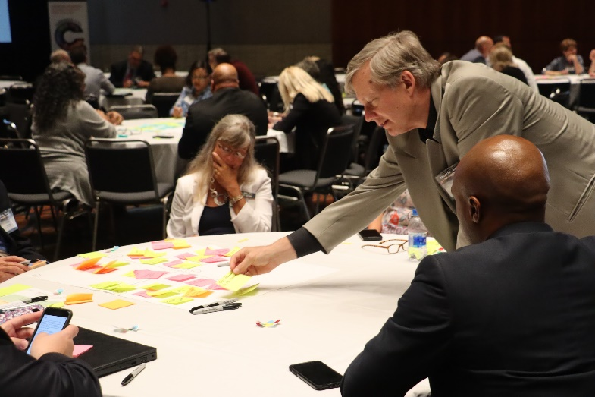

Divide. During the planning Jeanne Bonds, with the Federal Reserve Bank of Richmond, connected VDOE leadership with Digital Charlotte to share best practices of hosting a digital equity summit.

The conversation led to the suggestion of using design thinking principles to gather feedback from the summit participants on what and how they would like to see the VDOE address the issues related to digital inequities.

Ultimately, that is what happened. Digital Charlotte conducted a design jam at the last session of the pre-conference day. Roughly 50 attendees participated in a 90-minute design jam.

Digital Charlotte:
Digital Charlotte is an initiative of the Knight School of Communication at Queens University of Charlotte. The initiative began in 2010 when the school received a grant from the Knight Foundation and charged the newly minted school to bring together three key communities - the Queens University community, the regional community, and practitioners in digital and media literacy.
The design jam was conducted by Andrew Au and Bruce Clark of Digital Charlotte.
You can learn more about Digital Charlotte by visiting Digital Charlotte.

Design Jam:

This Design Jam was created using the Lightning Design Jam (LDJ) from AJ&Smart as our beginning framework. We chose the LDJ in order to cut out unnecessary discussion and replace it with a rapid creation of ideas and issues by the participants, ensuring everyone’s opinion is heard, and prioritize the best ones through votes to help speed up the time it takes to make decisions on what’s the important
next steps.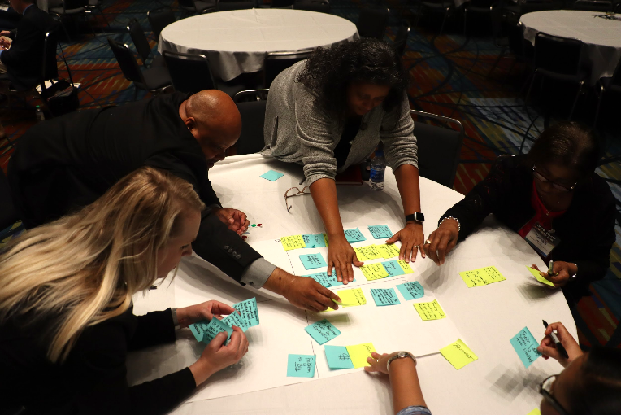

We modified the LDJ framework for our Design Jam to focus on the stated goal: “How might we bridge the learning @ home gap at your school?”, answer questions co-created with the VDOE and Digital Charlotte, and not get lost in having open-ended and unstructured discussions.

The results of the Design Jam allowed for many ideas and issues to be written down and allowed us to discover which ideas and issues are important amongst the people participating in the Design Jam.

Results:

The results listed below are highlights from the full data set. Please be sure to review the entire results document to see all responses. Link provided below.

- 50 people participated
- Over 370 inputs recorded over 45 minutes
- 39 peer-voted priorities

Question #1:
What is the VDOE doing to address the learning @ home gap?

Top prioritized responses:
- Having this conference
- Helping publicize the need for connectivity
- Helping creating communication lines between divisions

Question #2:
What is holding the VDOE back from ending the learning @ home gap?

Top responses:
- Broadband availability in rural and underserved areas
- Funding
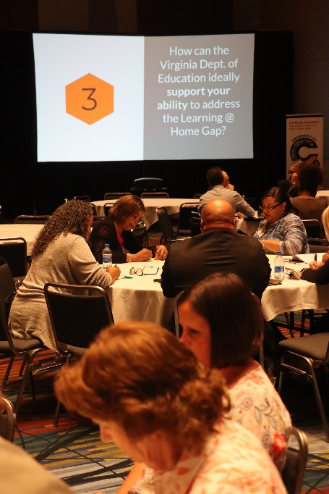
Question #3:
How can the VDOE ideally support your ability to address the learning @ home gap?

Top prioritized responses:
- Work with legislative/regulatory agencies to require statewide wireless broadband coverage
- Offer continuous training
- Provide more support for school divisions to find ways to obtain broadband
- Negotiate lower contract rates on other Ed resources to allow for reallocation of funds to broadband projects
- Regionally planning and working with school divisions and partnerships

Question #4:
How is your division affected by the digital divide in your school and home?

Top prioritized responses:
- Students under-prepared to be competitive in a global market/society
- Teachers won't assign homework requiring broadband access
- Teachers who have no internet access at home

Suggested Next Steps:

- Take time to review the linked results spreadsheet.
- On Top Ideas tab of the spreadsheet, complete the “Next Step” column to identify if an item falls within one of the provided categories.
- Identify the top ideas or issues that can be addressed with the lowest effort and gives the highest impact.
- Be sure to share these results with the participants with a clear call to action that you decide on after reviewing this report.
#####

Contact information:

Digital Charlotte
Knight School of Communication
Queens University of Charlotte
1900 Selwyn Ave
Charlotte, NC 28274
P: 980-552-1971

